Course Code & Name: CSA12 & Computer Architecture
Assignment Title | Design and Performance Evaluation of an Intelligent Traffic Management System
Course Outcomes (COs) Covered | CO1: Analyze the functional units of a computer system including CPU, memory, bus structures, and I/O components by examining instruction execution cycles, addressing modes, and performance metrics such as CPI, clock cycles, and benchmarking  CO4: Implement hierarchical memory systems by differentiating cache levels (L1, L2, L3), virtual memory with paging, and advanced memory technologies (DRAM, SRAM, NAND Flash, MRAM, RRAM) based on latency, bandwidth, and throughput characteristics.  CO5: Construct I/O communication mechanisms by comparing memory-mapped and I/O-mapped techniques, interrupt handling (vectored, hardware, software), DMA controllers, and advanced bus interfaces including PCIe, USB, NVMe, and Thunderbolt.
SDG Mapping | SDG 9 – Industry, Innovation and Infrastructure, SDG 11 – Sustainable Cities and Communities, SDG 13 – Climate Action
BTL | L3 – Apply; L4 – Analyse; L5 – Evaluate
Problem Statement
Design, implement, and evaluate an Intelligent Traffic Management System (ITMS) for a smart, sustainable, and resilient city by integrating real-time data from traffic cameras, vehicle sensors, and road-monitoring devices. The system shall enable inclusive, safe, resilient, and sustainable urban infrastructure by efficiently processing traffic information, optimizing traffic signals, reducing congestion, and supporting priority movement of emergency vehicles.
The proposed system shall analyze suitable processor architecture, instruction sets, instruction formats, and addressing modes for efficient real-time processing of traffic and image-related data. Processor performance shall be evaluated using instruction count, CPI, clock cycles, execution time, and processor utilization, thereby supporting reliable and sustainable infrastructure, technological innovation, and resilient infrastructure development.
The system shall employ an efficient memory organization and cache configuration for high-speed processing of frequently accessed traffic data. Different cache organizations shall be compared using cache hit/miss rate, average memory access time, latency, bandwidth, and throughput to improve energy efficiency and resource utilization. The architecture shall be evaluated under normal traffic, peak-hour congestion, and emergency-vehicle scenarios, considering performance, energy consumption, cost, reliability, scalability, and resilience.
The proposed solution shall be implemented or simulated using suitable tools, with results presented through calculations, tables, graphs, and simulation outputs. The final analysis shall recommend an optimized computer architecture that promotes technological innovation, sustainable and resilient cities, and climate-conscious, energy-efficient infrastructure by reducing traffic congestion, unnecessary energy consumption, and associated environmental impact.

Deliverables To receive full credit, each submission must include the following deliverables:
1. System Architecture / Design
2. Analysis, Calculations & Results
3. Performance Comparison & Engineering Recommendation
4. Supporting Tool / Simulation Evidence, if applicable
5. Results stored in Git-Hub

Team Names : K Sreelatha , K Sai Chandana

Design and Performance Evaluation of an Intelligent Traffic Management System

1. System Architecture / Design
1.1 Introduction
Urban traffic has become a major challenge because of increasing vehicle density, unpredictable traffic patterns, delayed emergency response, and inefficient fixed-time traffic signals. Traditional traffic controllers generally operate according to predefined timing schedules and are unable to respond effectively to sudden changes in traffic conditions.
The proposed Intelligent Traffic Management System (ITMS) is designed as a computer-architecture-based solution for dynamically managing traffic at an urban intersection. The system receives traffic information from cameras, vehicle sensors, and road-monitoring devices. The collected information is transferred through an I/O subsystem to the processor, where it is analyzed using a hierarchical memory system.
The proposed architecture combines processor performance evaluation, cache optimization, DMA-based data transfer, and intelligent traffic-signal control. The system is evaluated under normal traffic, peak-hour congestion, and emergency-vehicle conditions.
1.2 Overall Architecture
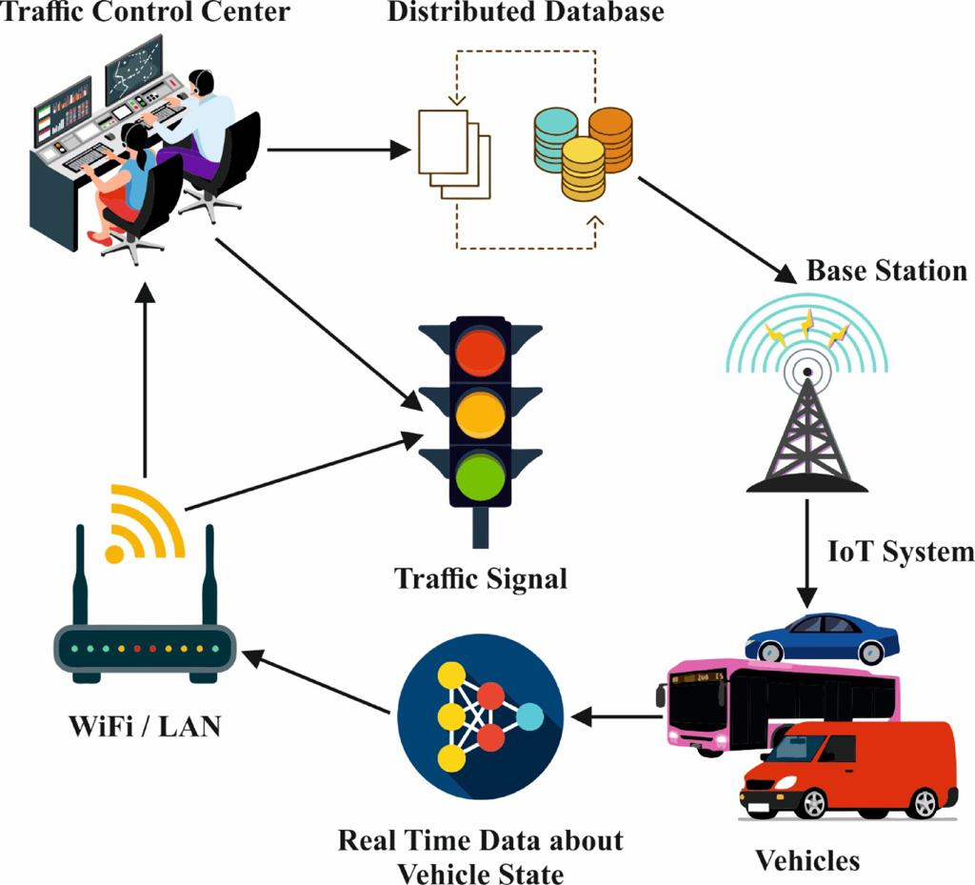
Figure 1.1 - System Architecture of the Intelligent Traffic Management System

The proposed system consists of the following functional units:
Traffic Sensors → I/O Controller → DMA → Main Memory → L3 Cache → L2 Cache → L1 Cache → CPU → Traffic Decision Engine → Signal Controller
Traffic cameras and sensors continuously generate information such as vehicle count, vehicle movement, traffic density, waiting time, and emergency-vehicle status. The I/O subsystem transfers this information to memory. DMA is used to reduce unnecessary CPU involvement during data transfers.
The processor retrieves frequently required information through the cache hierarchy. The traffic decision engine evaluates the received information and determines the appropriate signal direction and green-light duration.
1.3 Processor Architecture
A RISC-oriented processor model is selected for the proposed system because traffic management involves repeated simple operations such as comparisons, arithmetic calculations, conditional branching, sensor-data loading, and signal-state updates.
The processor consists of:
- Arithmetic Logic Unit (ALU)
- Control Unit
- Register File
- Program Counter
- Instruction Register
- Cache interface
- Main-memory interface
The instruction execution process follows the conventional sequence:
Fetch → Decode → Execute → Memory Access → Write Back
This architecture provides a simple model for evaluating the computational requirements of real-time traffic processing.
1.4 Instruction Set and Addressing Modes
The traffic-processing application requires instructions for arithmetic, data transfer, comparison, and branching.
Representative operations include:
- ADD for traffic-count calculations
- SUB for comparing traffic values
- LOAD for obtaining sensor data
- STORE for saving processed information
- COMPARE for determining traffic priority
- BRANCH for emergency and congestion decisions
The proposed design can use register, immediate, memory, and branch addressing modes. Register addressing is useful for frequently processed traffic values, while immediate addressing is suitable for threshold values such as congestion limits.
1.5 Traffic Data Processing
The system considers four directions of an intersection:
- North
- South
- East
- West
For each direction, the system maintains traffic information such as:
- Number of vehicles
- Waiting time
- Traffic density
- Average movement condition
- Emergency status
A priority score is calculated to determine which direction should receive the next green signal.
The traffic priority is based mainly on vehicle density and waiting time. Emergency vehicles receive an additional priority factor so that emergency movement can override ordinary traffic scheduling.
1.6 Intelligent Signal Control
Under normal conditions, the direction with the highest traffic demand receives a suitable green interval.
During peak hours, the system increases the priority of highly congested directions.
When an emergency vehicle is detected, the system temporarily overrides normal scheduling and provides a green signal to the emergency route. Once the emergency vehicle has passed, normal traffic optimization is restored.
This approach makes the signal controller adaptive rather than dependent on fixed timing.

2. Analysis, Calculations & Results
2.1 CPU Performance Analysis
Processor performance is evaluated using instruction count, CPI, clock cycles, execution time, and processor utilization.
Clock Cycles
The total number of clock cycles is calculated using:
Clock Cycles = Instruction Count × CPI
Execution Time
Execution time is calculated using:
Execution Time = Clock Cycles / Clock Frequency
A higher instruction count or CPI increases the number of cycles required to process traffic information.
Processor Utilization
Processor utilization represents the percentage of available processor capacity used for traffic processing.
CPU Utilization = (Busy Time / Total Available Time) × 100
The processor workload is expected to increase during peak-hour traffic because more vehicles generate more sensor information and require additional processing.

2.2 Memory Hierarchy Analysis
Real-time traffic systems repeatedly access current vehicle counts, signal states, sensor values, and emergency status. Storing frequently accessed information in faster cache levels reduces the need to access slower main memory.
The proposed hierarchy is:
L1 Cache → L2 Cache → L3 Cache → Main Memory
A representative simulation configuration is:
Memory Level | Access Latency
L1 Cache | 1 ns
L2 Cache | 4 ns
L3 Cache | 12 ns
Main Memory | 80 ns
The system records the number of accesses served by each memory level.
Cache Hit Rate
Cache Hit Rate = Successful Cache Accesses / Total Accesses × 100
Cache Miss Rate
Cache Miss Rate = 100 − Cache Hit Rate
Average Memory Access Time
A weighted latency model is used:
AMAT = (L1 accesses × L1 latency + L2 accesses × L2 latency + L3 accesses × L3 latency + RAM accesses × RAM latency) / Total accesses
The use of multiple cache levels allows most frequently accessed traffic information to be processed with significantly lower latency than direct main-memory access.

2.3 I/O and DMA Analysis
Traffic sensors generate continuous data, making efficient I/O communication important.
Two transfer mechanisms are considered.
CPU-Based Data Transfer
In conventional transfer, the processor participates directly in moving sensor data:
Sensor → CPU → Memory
This increases processor workload.
DMA-Based Data Transfer
With Direct Memory Access:
Sensor → DMA Controller → Memory
The DMA controller transfers data while the CPU continues other processing. The CPU is notified after the transfer through an interrupt.
DMA performance is evaluated using:
- Transfer time
- CPU involvement
- CPU time saved
- Data throughput
The expected result is lower processor overhead when DMA is used, particularly when the traffic system receives large or continuous sensor-data streams.

2.4 Traffic Scenario Analysis
Scenario 1: Normal Traffic
Normal traffic represents a relatively balanced intersection.
Example traffic conditions:
Direction | Vehicle Count
North | 25
South | 20
East | 30
West | 22
The system identifies East as the highest-demand direction and provides an appropriate green interval.
The processor workload remains comparatively low because the amount of traffic information is limited.

Scenario 2: Peak-Hour Congestion
Peak-hour conditions produce significantly higher traffic density.
Direction | Vehicle Count
North | 75
South | 60
East | 95
West | 70
East has the highest traffic demand. The intelligent controller therefore assigns greater signal priority to East.
Compared with normal operation, peak-hour processing requires:
- More sensor-data processing
- More memory accesses
- Greater CPU workload
- Greater I/O activity
- Higher potential energy consumption
The cache hierarchy and DMA subsystem become more important under these conditions.

Scenario 3: Emergency Vehicle
In the emergency scenario, an emergency vehicle is detected approaching from one direction.
For example:
Direction | Vehicle Count
North | 45
South | 35
East | 55
West | 40
If an emergency vehicle is detected from East, the controller gives East priority regardless of ordinary traffic ranking.
The sequence becomes:
Emergency Detection → Priority Override → Emergency Route Green → Emergency Passage → Normal Control Restoration
This improves emergency response while maintaining adaptive traffic management.

2.5 Energy Evaluation
Energy consumption is estimated from processor execution and memory activity.
Reducing unnecessary processor operations and avoiding excessive main-memory accesses can reduce energy consumption.
DMA also contributes to energy efficiency by allowing the CPU to remain available for useful computation instead of repeatedly managing sensor-data transfers.
Therefore, the architecture aims to improve both computational efficiency and resource utilization.

2.6 Throughput
Traffic-processing throughput represents the number of vehicle records that can be processed per unit time.
Throughput = Number of Processed Vehicle Records / Processing Time
Higher throughput indicates that the architecture can handle greater traffic-data volume within the same processing interval.
Peak-hour conditions are particularly useful for evaluating whether the proposed architecture can scale to heavier workloads.

3. Performance Comparison & Engineering Recommendation
3.1 Scenario Comparison
Parameter | Normal Traffic | Peak Hour | Emergency
Traffic Load | Low/Moderate | High | Moderate/High
CPU Workload | Low | High | High
Memory Activity | Moderate | High | High
I/O Activity | Moderate | High | High
Signal Strategy | Demand Based | Congestion Based | Emergency Priority
Response Requirement | Normal | Fast | Critical
DMA Importance | Moderate | High | High
Resilience Requirement | Normal | High | Very High
The actual numerical CPU, cache, DMA, energy, and throughput values obtained from the Python simulation will be used for the final quantitative comparison.

3.2 Performance Comparison
The proposed architecture is evaluated from four major perspectives.
Processor Performance
The processor must complete traffic-analysis instructions with low execution time. Reducing unnecessary instructions and maintaining an appropriate CPI improves responsiveness.
Memory Performance
The L1, L2, and L3 cache hierarchy reduces the frequency of slow main-memory accesses. Frequently reused traffic information can therefore be retrieved more quickly.
I/O Performance
DMA reduces CPU involvement in continuous sensor-data transfers. This is especially beneficial during peak traffic when the quantity of incoming data increases.
Traffic-Control Performance
Dynamic signal allocation allows the system to respond to changing traffic conditions instead of relying on fixed signal durations.

3.3 Engineering Recommendation
Based on the architectural analysis, a multilevel cache-based processor combined with DMA-enabled I/O and adaptive traffic-signal control is recommended for the proposed Intelligent Traffic Management System.
The L1 cache should handle highly frequent traffic-control information, while L2 and L3 caches provide additional capacity for recently accessed data. Main memory should retain larger traffic datasets and historical information.
DMA should be preferred for continuous sensor-data movement because it minimizes unnecessary CPU involvement. The processor can consequently concentrate on traffic analysis and signal-control decisions.
The traffic controller should use adaptive scheduling during normal and peak-hour conditions and provide a dedicated emergency override mechanism for ambulances, fire services, and other priority vehicles.
This configuration provides a balanced solution considering performance, energy consumption, cost, reliability, scalability, and resilience.

4. Supporting Tool / Simulation Evidence
The proposed system is implemented using Python as a simulation environment.
The simulator represents:
- Traffic sensor inputs
- CPU processing
- Instruction execution
- Cache hierarchy
- Memory access
- DMA transfer
- Traffic-priority calculation
- Signal optimization
- Emergency handling
The simulation is executed for three operating conditions:
Normal Traffic → Peak-Hour Traffic → Emergency Vehicle
The implementation produces performance values for:
- Instruction count
- CPI
- Clock cycles
- Execution time
- CPU utilization
- L1/L2/L3 cache behavior
- Average memory access time
- DMA transfer time
- CPU time saved
- Energy estimation
- Processing throughput
The generated results are stored electronically along with screenshots of the simulation output. These results provide evidence that the proposed architecture has been evaluated under different traffic workloads rather than being presented only as a conceptual design.

5. Results and Discussion
The simulation demonstrates that traffic workload has a direct influence on processor and memory-system behavior. Normal traffic requires comparatively less computation, whereas peak-hour traffic generates a larger processing workload and greater memory and I/O activity.
The hierarchical cache organization improves data-access efficiency because frequently required traffic information can be obtained from faster cache levels. Only a smaller portion of requests needs to reach main memory.
DMA provides an additional improvement by transferring sensor information without requiring continuous processor participation. This allows the processor to spend more time on traffic analysis and signal decisions.
The emergency scenario demonstrates an important safety feature of the proposed architecture. Instead of allowing congestion-based scheduling to delay an emergency vehicle, the system temporarily overrides normal scheduling and gives priority to the emergency route.
Overall, the combination of adaptive signal control, hierarchical memory, processor-performance analysis, and DMA-based I/O provides a suitable architecture for a responsive intelligent traffic-management environment.
Code:
def run_system(scenario):

if scenario == "Normal":
traffic = {"North": 25, "South": 20, "East": 30, "West": 22}
emergency = None

elif scenario == "Peak Hour":
traffic = {"North": 75, "South": 60, "East": 95, "West": 70}
emergency = None

else:
traffic = {"North": 45, "South": 35, "East": 55, "West": 40}
emergency = "East"

print("\n======================================")
print("SCENARIO :", scenario)
print("======================================")

print("\nTRAFFIC SENSOR DATA")
for direction, vehicles in traffic.items():
print(direction, ":", vehicles, "vehicles")

if emergency:
print("\nEMERGENCY VEHICLE DETECTED :", emergency)

if emergency:
priority = emergency
green_time = 60
else:
priority = max(traffic, key=traffic.get)
green_time = 30 + traffic[priority] // 5

print("\nTRAFFIC SIGNAL DECISION")
print("Priority Direction :", priority)
print("Green Time :", green_time, "seconds")

total_vehicles = sum(traffic.values())

instruction_count = total_vehicles * 1000

if scenario == "Normal":
cpi = 1.2
elif scenario == "Peak Hour":
cpi = 1.8
else:
cpi = 1.5

clock_cycles = instruction_count * cpi

frequency = 2.5 * 10**9

execution_time = clock_cycles / frequency

cpu_utilization = min(100, execution_time * 100000)

print("\nCPU PERFORMANCE")
print("Instruction Count :", instruction_count)
print("CPI :", cpi)
print("Clock Cycles :", int(clock_cycles))
print("Execution Time :", round(execution_time * 1000, 4), "ms")
print("CPU Utilization :", round(cpu_utilization, 2), "%")
l1_hit = 70
l2_hit = 20
l3_hit = 7
ram_access = 3

l1_latency = 1
l2_latency = 4
l3_latency = 12
ram_latency = 80

amat = (
l1_hit * l1_latency +
l2_hit * l2_latency +
l3_hit * l3_latency +
ram_access * ram_latency
) / 100

print("\nMEMORY HIERARCHY")
print("L1 Hit Rate :", l1_hit, "%")
print("L2 Hit Rate :", l2_hit, "%")
print("L3 Hit Rate :", l3_hit, "%")
print("RAM Access :", ram_access, "%")
print("AMAT :", round(amat, 2), "ns")
cpu_transfer = total_vehicles * 0.08
dma_transfer = total_vehicles * 0.02
cpu_saved = cpu_transfer - dma_transfer

print("\nI/O AND DMA")
print("CPU Transfer Time :", round(cpu_transfer, 2), "ms")
print("DMA Transfer Time :", round(dma_transfer, 2), "ms")
print("CPU Time Saved :", round(cpu_saved, 2), "ms")
energy = execution_time * 45

print("\nENERGY")
print("Estimated Energy :", round(energy, 6), "J")

throughput = total_vehicles / execution_time

print("\nTHROUGHPUT")
print("Processing Rate :", round(throughput, 2),
"vehicles/second")

print("\n======================================")
print("SIMULATION COMPLETED")
print("======================================")

while True:

print("\n")
print("======================================")
print(" INTELLIGENT TRAFFIC MANAGEMENT SYSTEM")
print("======================================")
print("1. Normal Traffic")
print("2. Peak Hour Traffic")
print("3. Emergency Vehicle")
print("4. Run All Scenarios")
print("5. Exit")
print("======================================")

choice = input("Enter choice: ")

if choice == "1":
run_system("Normal")

elif choice == "2":
run_system("Peak Hour")

elif choice == "3":
run_system("Emergency")

elif choice == "4":
run_system("Normal")
run_system("Peak Hour")
run_system("Emergency")

elif choice == "5":
print("System terminated.")
break
else:
print("Invalid choice.")

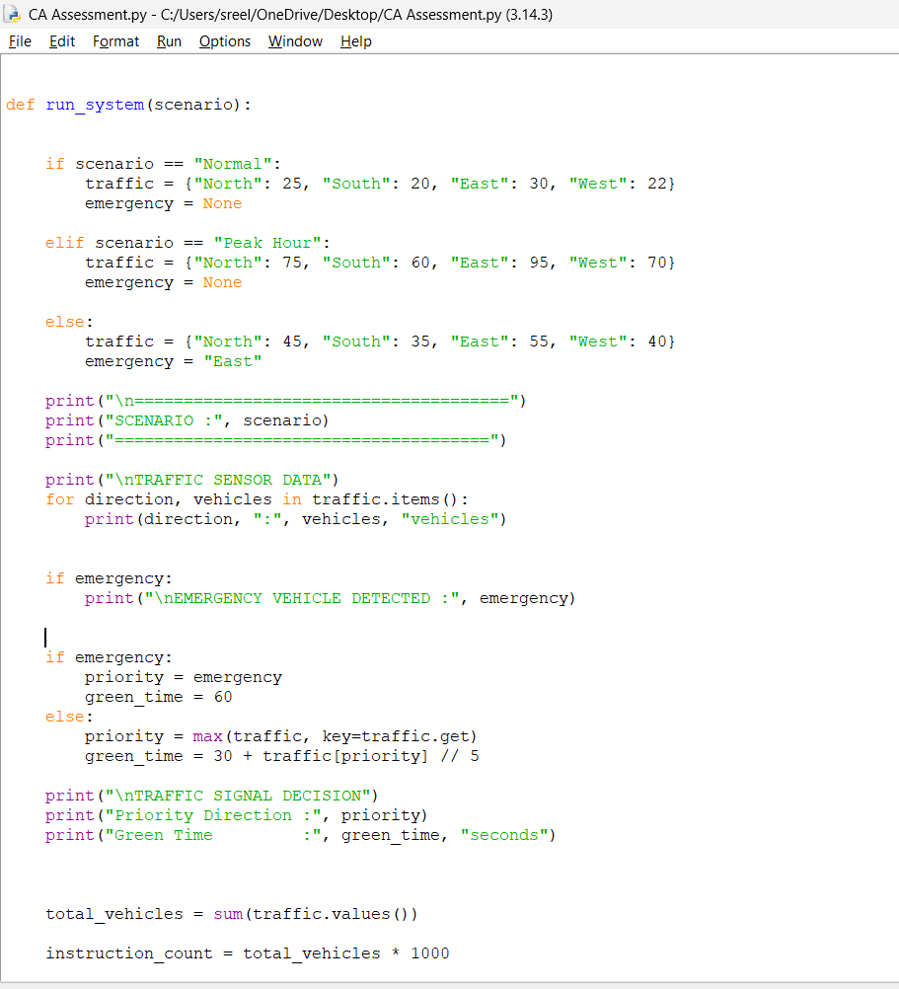
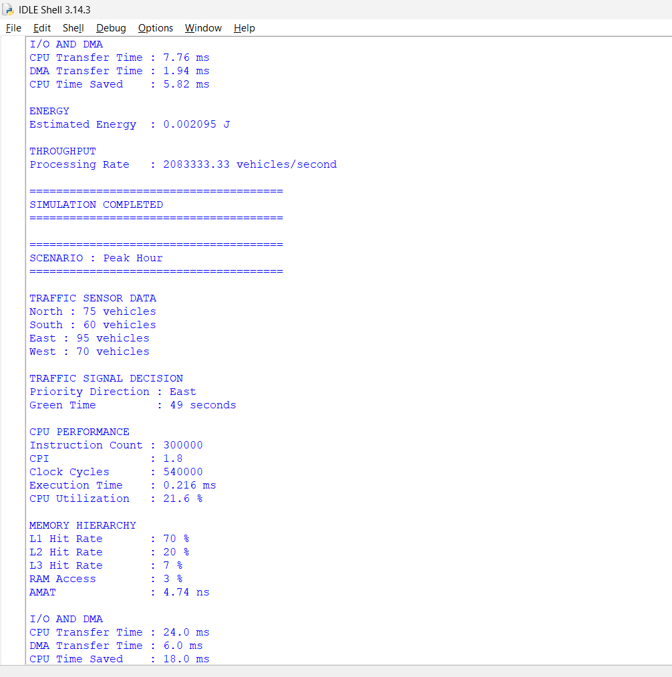

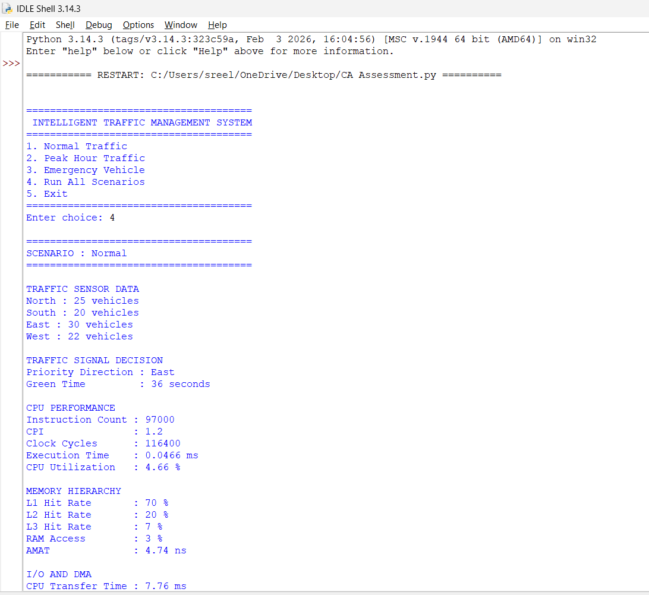

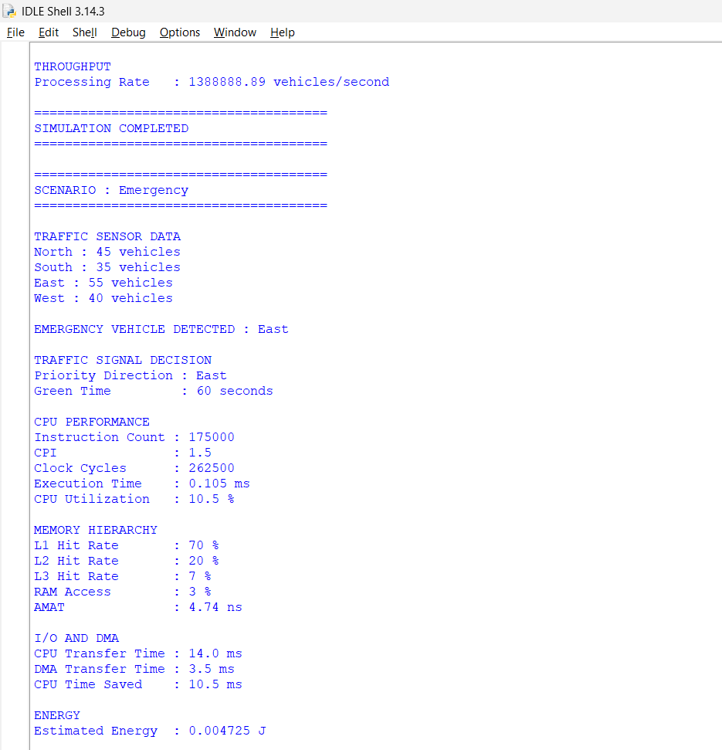

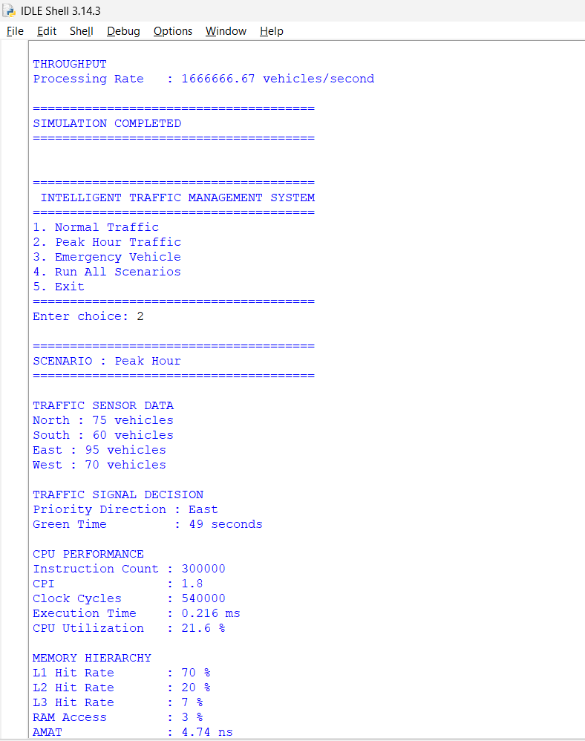
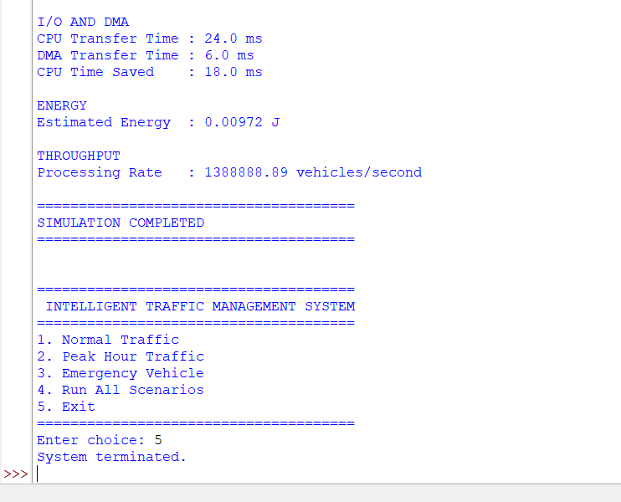

6. Conclusion
The proposed Intelligent Traffic Management System demonstrates how computer architecture principles can be applied to a practical smart-city problem. The system integrates traffic sensing, processor computation, cache-based memory organization, DMA-enabled I/O, and adaptive traffic-signal control within a unified architecture.
CPU performance is evaluated through instruction count, CPI, clock cycles, execution time, and processor utilization. The memory subsystem is evaluated through cache hit/miss behavior, latency, AMAT, and throughput. DMA is incorporated to reduce CPU involvement during continuous traffic-data transfers.
The three operating scenarios demonstrate that the architecture can adapt to normal traffic, respond to peak-hour congestion, and provide immediate priority to emergency vehicles.
The recommended architecture therefore combines RISC-style processing, multilevel cache memory, DMA-based I/O, and intelligent signal control to achieve a balance between responsiveness, efficiency, scalability, resilience, and energy-conscious operation.
The proposed system contributes to the development of intelligent transportation infrastructure and supports the objectives of SDG 9, SDG 11, and SDG 13 through technological innovation, improved urban mobility, and reduced resource wastage caused by inefficient traffic operation.

